****

**User’s Guide**

**v1.0.0**

Additional information on SpiderSuite can be found on the official online wiki which is updated regularly: <https://github.com/3nock/SpiderSuite/wiki>

Also see: <https://SpiderSuite.github.io/docs/>

# TABLE OF CONTENTS

[TABLE OF CONTENTS 1](#_Toc133921489)

[OVERVIEW 3](#_Toc133921490)

[Product Overview 3](#_Toc133921491)

[Features 3](#_Toc133921492)

[Requirements 3](#_Toc133921493)

[INSTALLATION 4](#_Toc133921494)

[To Download 4](#_Toc133921495)

[To Install 5](#_Toc133921496)

[To Uninstall 6](#_Toc133921497)

[USER INTERFACE 7](#_Toc133921498)

[Main Window 7](#_Toc133921499)

[Menu & Tool Bar 8](#_Toc133921500)

[Sitemap View 10](#_Toc133921501)

[Request View 10](#_Toc133921502)

[Structure View 11](#_Toc133921503)

[Source View 12](#_Toc133921504)

[Graph View 12](#_Toc133921505)

[CONFIGURATION 13](#_Toc133921506)

[Limits Configuration 13](#_Toc133921507)

[Crawler Configuration 16](#_Toc133921508)

[Request Headers Configuration 21](#_Toc133921509)

[Input Fields Configuration 22](#_Toc133921510)

[Exclusion Configuration 23](#_Toc133921511)

[Authentication Configuration 24](#_Toc133921512)

[Proxy Configuration 25](#_Toc133921513)

[Graph Configuration 26](#_Toc133921514)

[Configure Exports 27](#_Toc133921515)

[Passive Crawler Configuration 28](#_Toc133921516)

[Misc Configuration 29](#_Toc133921517)

[CRAWLING 30](#_Toc133921518)

[Configure the crawler 30](#_Toc133921519)

[Crawling from a Single Link 31](#_Toc133921520)

[Advance Crawling 33](#_Toc133921521)

[Crawling target with initial seed links 34](#_Toc133921522)

[Fetching list of links 35](#_Toc133921523)

[Bruteforcing pages / directories 36](#_Toc133921524)

[Sitemap 37](#_Toc133921525)

[Graph 39](#_Toc133921526)

[TOOLS 42](#_Toc133921527)

[Passive Crawler Tool 42](#_Toc133921528)

[SSL Certificates Tool 43](#_Toc133921529)

[Decoder Tool 44](#_Toc133921530)

[Search Tool 45](#_Toc133921531)

[Compare Tool 46](#_Toc133921532)

[CONTACTS 48](#_Toc133921533)

# OVERVIEW

## Product Overview

**Spider Suite** is an Advance Multi-feature web Crawler/Spider for Cyber Security professionals. It contains a powerful crawler which can crawl even the most sophisticated web pages and produce a readable output and an intuitive user interface to interact with the results.

SpiderSuite is a tool that can be easily utilized by web application developers, penetration testers, bug bounty hunters and cyber security researchers to map a target website and inspect each individual page and assets.

SpiderSuite contains a suite of tools aimed at easing the recon phase of web penetration testing and gives a detailed overview of the attack surface of a web application.

## Features

* Advance crawler which can crawl an entire target site fast.
* Bruteforce Crawling. Can crawl a target by bruteforcing pages.
* Extract important contents from the crawled pages such as scripts, styles and comments embedded in the webpage.
* Graph visualization of the entire crawled surface or a branch of the crawled surface.
* Import crawled pages from other web security crawlers and tools such as burp suite, Fiddler, Katana and Caido.
* Compare crawled pages and entire crawl projects.
* Export crawled links to different output formats such as CSV, JSON, XML, HTML and Sitemap.xml.

## Requirements

SpiderSuite runs on 64 bit machines only, it does not support x32 system and currently available for Windows and Linux operating systems.

# INSTALLATION

Installing SpiderSuite involves a series of simple steps which must be completed in the correct sequence for the installation to be successful.

***NOTE:******vX.X.X*** *refers to the version number e.g.* ***v1.0.0***

## To Download

The installers and portable executable files are available on the SpiderSuite’s Github repository <https://github.com/3nock/SpiderSuite/releases> page or official website <https://spidersuite.github.io/download/> download page

SpiderSuite currently supports Windows and Linux operating systems with x64 architecture.

On the release page there are two types of download packages for each of the two systems i.e. **installers** and **portable executables**.

**Installers:**

Installers will install SpiderSuite and its dependencies in default chosen location on your machine.

The installers are ***SpiderSuite\_vX.X.X\_win64\_installer.exe*** for windows and ***SpiderSuite\_vX.X.X\_linux\_installer.run*** for linux.

**Portable executables:**

Portable executables do not need any installation; you simply download and use directly.

The portable executables are ***SpiderSuite\_vX.X.X\_win64.zip*** for Windows and ***SpiderSuite\_vX.X.X\_linux.AppImage*** and ***SpiderSuite\_vX.X.X\_linux.tar.gz*** for Linux

## To Install

Please Note: SpiderSuite is a Graphical User Interface application so all of the steps in this guide refer to the SpiderSuite GUI.

**For Windows Portable Executables:**

Download and extract ***SpiderSuite\_vX.X.X\_win64.zip*** archive and place it at your chosen location, extract the archive then run SpiderSuite.exe simply by double clicking on the program.

**For Linux Portable Executable:**

Download ***SpiderSuite\_vX.X.X\_linux.AppImage*** and place it at your chosen location, then run it simply by **double clicking or** using command line with the command:

*./SpiderSuite\_vX.X.X\_linux.AppImage*

Download ***SpiderSuite\_vX.X.X\_linux.tar.gz*** archive and place it at your chosen location.

Extract the archive on desired location (you can use GUI option or command line:

*tar –xzf SpiderSuite\_vX.X.X\_linux.tar.gz*

Then run it simply by double clicking on the ***SpiderSuite/SpiderSuite*** or using command line with the command

*./SpiderSuite/SpiderSuite*

**For Windows Installer:**

Download ***SpiderSuite\_vX.X.X\_win64\_installer.exe*** then run the installer, then fill in the required information such as installation location and shortcut names procedurally until you finish the installation procedure.

**For Linux Installer:**

Download ***SpiderSuite\_vX.X.X\_linux\_installer.run*** then run the installer by double clicking it or using the command line :

./SpiderSuite\_vX.X.X\_linux\_installer.run

Then fill in the required information such as installation location and shortcut names procedurally until you finish the installation procedure.

***NOTE:***

*In most windows environment SpiderSuite will run on the first try but case of SipderSuite fails to run on the first try on windows, this could be an indication that your machine does not contain the required MSVC-redistributable package.*

*Worry not SpiderSuite comes packaged with the required MSVC-redistributable package in case of this.*

*Simply Install the MSVC-redistributable package which comes with SpiderSuite (****SpiderSuite/vcredist\_x64.exe****)*

*Also In case SpiderSuite fails to connect to the internet and shows SSL errors, install the OpenSSL package which comes packaged with SpiderSuite (****SpiderSuite/Win64 OpenSSL v1.1.1n Light.msi****).*

## To Uninstall

To uninstall SpiderSuite for portable SpiderSuite, just delete the ***SpiderSuite*** folder or the ***SpiderSuite.AppImage*** and you are done. For installed SpiderSuite run the maintenance tool located in the SpiderSuite’s installation directory (***SpiderSuite/maintanancetool.exe*** in windows and ***SpiderSuite/maintanancetool*** in linux).

# USER INTERFACE

## Main Window

SpiderSuite’s Main window contains the following information.

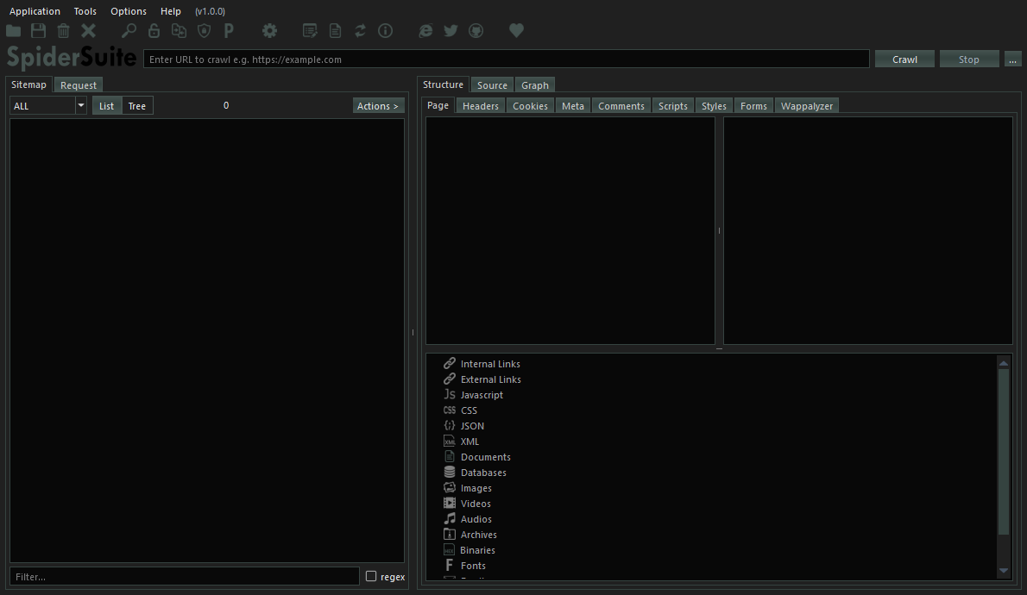

* Menu & Tool bar
* Sitemap View
* Request View
* Structure View
* Source View
* Graph View

### Menu & Tool Bar

Contains actions that can be performed on the application and the project.

* **Application**
  + - **Open** - opens a project from the file system.
    - **Open Recent** - shows and opens recent SpiderSuite projects you’ve been working on.
    - **Import From** - Imports links and their data from other tools and file types such as:

- Links from CSV files

- Links from Sitemap files

- Links from Zed Attack Proxy(ZAP),

- Links from acunetix(.xml files),

- Data from Fiddler(.saz files),

- Data exported from BurpSuite(.xml files),

- Data from HTTP Archives(.har files)

- Data from Caido (CSV & JSON files)

- Data from Katana crawler (INDEX and JSON files)

* + - **Save** - Saves the current project you’re working on without closing it.
    - **Clear** – Clears and deletes all the data of the current loaded project.
    - **Close** - closes the current loaded project without deleting any data from that particular project.
    - **Exit** - Closes the application.
* **Tools**
  + - **Search Tool** – Searches the current project’s data in the database and returns all the pages that contains that particular search query. The search can take a long or short period depending on the size of the project.
    - **Decoder Tool** – Encodes, Decodes or hashes the input data using the chosen encoding, decoding or hashing algorithm. Many other encoding, decoding and hashing algorithms will be added in the coming versions.
    - **Compare Tool** - compares two different pages or crawls then highlights the differences and similarities of the two pages or crawls.
    - **SSL certificates Tool** - Fetches SSL certificates of a particular target hostname. It does this by trying to establish a secure connection to the hostname and when done it returns the target hostname SSL certificate and closes the connection.
    - **Passive Crawler Tool** - Uses OSINT (open source intelligence) sources such as ***waybackmachine*** to obtain all publicly available url links of a particular target. You can use the obtained links as seed links for the next crawl as it broadens the crawlers scope.
* **Options**
  + - **Preferences** - All program’s settings and scan configurations.
* **Help**
  + - **Log Viewer** - Displays all scan and program logs.
    - **Documentation** - Takes you to the official documentation of SpiderSuite
    - **Donate** - Takes you to a page for donating to the SpiderSuite project.
    - **Website** - Takes you to SpiderSuite official website where you can find all the all information, blog and documentation on SpiderSuite.
    - **Twitter** - Takes you to official Spider Suite’s twitter page.
    - **Github** - Takes you to official Spider Suite’s Github repository page
    - **Check For Updates** - checks for any available SpiderSuite updates from the repository.
    - **About** - Information about SpiderSuite.
    - **About Qt** - Information about Qt C++ Framework used to create SpiderSuite.

### Sitemap View

Displays the crawled pages or pages imported from other tools.

* **Types ComboBox**

Filters the types of pages to display on the sitemap i.e:

- All (displays all page type)

- HTML (displays only html files)

- Javascript (displays only javascript files)

- CSS (displays only CSS files)

- JSON (displays only JSON files)

- XML (displays only XML files)

- Image (displays only image files)

- Audio (displays only audio files)

- Video (displays only video files)

- Documents (displays only document files)

- Database (displays only database files)

- Archive (displays only archive files)

- Binary (displays only binary files)

- Font (displays only font files)

- Misc (displays miscellaneous files)

* **List** - Displays the pages crawled in a list format
* **Tree** - Displays the pages crawled in a tree hierarchical structure
* **[Action >] button** - Provides a menu of actions that you can perform on the displayed sitemap pages.

### Request View

Preforms HTTP(S) request on the provided target then saves and display the results.

This feature is useful for performing manual tests on a target. The requests are sent one after another and you can only send another request when the previous request has elicited a response.

* **HTTP version ComboBox** - Choose the HTTP version (HTTP/1.X or HTTP/2.X) to use for request.
* **Method type ComboBox** - Choose the Method (GET, POST, PUT, DELETE) to use for HTTP request.
* **Headers List** - Input request headers to use for request.
* **Query data TextEdit** - Input the query data to send with request for POST & PUT methods only.
* **History List** - Displays the pages that you have requested, you can access the pages content by simply clicking on them.

### Structure View

Displays the contents extracted from the crawled pages. Click on a page in Sitemap or Request History to access the page's contents in structure view.

* **Page Tab** - Displays basic information extracted from the page such as size, content type, method used and all links extracted from the page.
* **Headers Tab** - Displays all the request and response headers extracted from the http request and response.
* **Cookies Tab** - Displays all the request and response cookies extracted from the http request and response headers.
* **Meta Tab** - Displays all the meta information extracted from the `<meta>` tag in html page.
* **Comments Tab** - Displays all the code comments extracted from the page source.
* **Scripts Tab** - Displays all the Javascript code extracted from the `<script>` html tag.
* **Styles Tab** - Displays all the CSS code extracted from the `<style>` html tag.
* **Forms Tab** - Displays all the html forms extracted from the html `<form>` tag.
* **Wappalyzer Tab** - Detects and Displays all the web technologies used on that page.

### Source View

Displays the source (response body) of the crawled page. Click on a page in Sitemap or Request History to access the page's source in Source view.

* **Text View** - Displays the page's source in Text format.
* **Hex View** - Displays the page's source in Hexadecimal format.
* **Tree view** - Displays the page's source in a tree format (available for html, xml, JSON and CSS files only for now).
* **Image View** - Displays the image (available for image files only)

### Graph View

The Graph View Visualizes the crawled pages on a graph. It can visualize either the entire sitemap of a branch of the pages from the sitemap tree view.

Uses two types graph layouts (Dot and SFDP layout), three types of node shapes (Rectangle, elliptical and point shapes) and node colors of your choosing.

# CONFIGURATION

SpiderSuite Configurations are stored in JSON format in a ***SpiderSuite.conf*** configuration file that is located in the installation folder of SpiderSuite.

You can easily modify the configuration values and save for the changes to take place. You can also easily reset the configurations to default values that come with SpiderSuite, any changes saved or reset will also reset the SpiderSuite.conf file.

## Limits Configuration

Configurations for Crawler’s limitations.

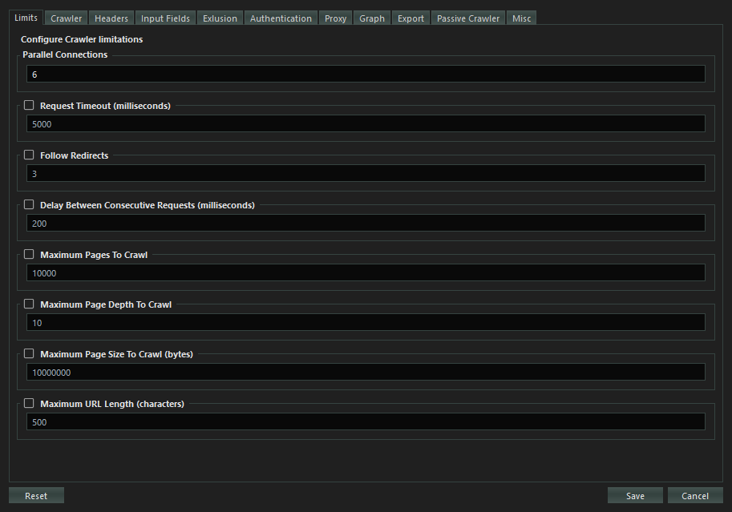

**Parallel Connections:**

Sets the number of parallel connections to connect to the target server with during crawling. According to Spider Suite’s design, 6 connections is the most optimal configuration value as Spider Suites employs other techniques to increase the efficiency of the spider such as; use of HTTP pipelining and HTTP2 multi-plexing.

**Timeout:**

Sets the maximum waiting duration in milliseconds for a request to elicit a response from the target server.

***If checked (set to true),*** when maximum timeout is reached and there is no response from target server the request will be aborted and closed.

***If unchecked (set to false),*** the request will remain active until it gets a response from server or until the 30 seconds threshold is reached.

**Follow Redirects:**

Sets the following of the redirect URL in case of a 3XX response status and the maximum number of redirects to follow.

***If checked (set to true),*** when a request elicits a 3XX redirect response, the crawler will automatically redirect to the received redirection URL. You can also set the maximum number of redirects to follow.

***If unchecked (set to false),*** when a 3XX response is received the crawler will not redirect the request, it will simply save the result and continue to crawl other links

**Delay between Consecutive Requests:**

Sets the wait time between sending consecutive requests. The delay is configured in milliseconds.

***If checked (set to true),*** when spider sends a request to the target server it will wait for XXX milliseconds before sending another request to that target server.

***If unchecked (set to false),*** the spider will send multiple requests in a tight loop to the target server.

This should only be checked (set to true) in cases of targets that

* Can’t handle too many requests
* Detects and prevents high speed crawling
* Has strict crawling rules

Otherwise it slows down the crawling process, as the spider has to delay for XXX milliseconds before sending another request.

**Maximum Pages to Crawl:**

Sets the maximum number of successful result pages to be crawled. This only takes into account the successfully crawled pages from the target server.

***If checked(set to true),*** when the spider successfully crawls the XXX number of pages from the target server the spider will automatically stop regardless whether there are still crawlable links available

***If not checked (set to false),*** the spider will crawl the target site until either you stop the crawling manually or until the spider finishes crawling all the links.

**Maximum Crawl Depth:**

Sets the maximum page depth to crawl for a particular target. Depth refers to the position of the page from the host domain.

e.g. *https://www.example\_domain.com/depth\_1/ depth \_2/ depth\_3?name=value*

***If checked (set to true),*** the spider will not crawl a page whose depth exceeds the maximum crawl depth. Only pages whose depth are between 0 and max crawl depth will be crawled.

***If not checked (set to false),*** the spider will crawl all pages of all depths of the particular target.

**Maximum Page Size to Crawl:**

Sets the maximum page size in bytes for download.

***If checked (set to true),*** pages whose size is above the maximum page download size will not be downloaded.

***If not checked (set to false),*** pages of all sizes will be downloaded and crawled.

**Maximum URL Length:**

Sets the maximum allowed length in bytes/characters for a URL link.

***If checked (set to true),*** links whose length is above the maximum link length value will not be crawled.

***If not checked (set to false),*** links of all lengths will be crawled.

## Crawler Configuration

Crawler specific configurations.

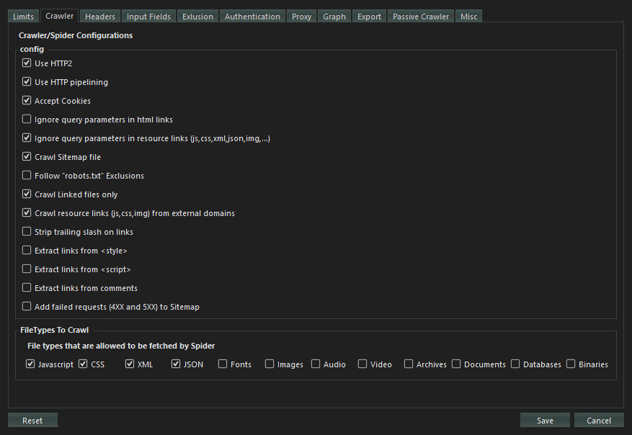

**Use HTTP2:**

Configures the use of HTTP version 2 protocol for request to the target server. If a server turns out to not support HTTP/2 the spider will fall back to using HTTP version 1 by default.

HTTP/2 is the second version of the HTTP protocol aiming to make applications faster, simpler, and more robust by improving many of the drawbacks of the first HTTP version. Has features including;

* **Binary protocols** – Binary protocols consume less bandwidth, are more efficiently parsed and are less error-prone than the textual protocols used by HTTP/1.1.
* **Multiplexing** – HTTP/2 is multiplexed, i.e., it can initiate multiple requests in parallel over a single TCP connection. As a result, web pages containing several elements are delivered over one TCP connection.
* **Header compression** – HTTP/2 uses header compression to reduce the overhead caused by TCP’s slow-start mechanism.
* **Server push** – HTTP/2 servers push likely-to-be-used resources into a browser’s cache, even before they’re requested. This allows browsers to display content without additional request cycles.
* **Increased security** – Web browsers only support HTTP/2 via encrypted connections, increasing user and application security.

**HTTP Pipelining:**

Configures the spider to use http-pipelining technique to increase speed and efficiency. Works when using HTTP/1.

HTTP pipelining is a feature of HTTP/1.1 which allows multiple HTTP requests to be sent over a single TCP connection without waiting for the corresponding responses.

HTTP/1.1 requires servers to respond to pipelined requests correctly, with non-pipelined but valid responses even if server does not support HTTP pipelining. Despite this requirement, many legacy HTTP/1.1 servers do not support pipelining correctly, forcing most HTTP clients to not use HTTP pipelining.

The technique was superseded by multiplexing via HTTP/2.

**Accept Cookies:**

Configures the spider to accept and use cookies sent by the target server. The spider will store the cookie and send it back to the same server with later requests.

An HTTP cookie (web cookie, browser cookie) is a small piece of data that a server sends to a user's web browser (in this case SpiderSuite). Cookies are mainly used for three purposes: Session management, Personalization & Tracking.

**Ignore query parameters in html links:**

Configures the crawler to ignore all query parameters in all html links it crawls.

e.g. *https://example.com?param1=1&param2=2 => https://example.com*

**Ignore query parameters in Resource links:**

Configures the crawler to ignore all query parameters in resource links only. Resource links here refers to links which are not of html file type e.g. js, css, xml, json links.

**Crawl sitemap File:**

Configures the crawler to first fetch sitemap.xml file is the site contains one. If the site does possess the sitemap.xml file then the spider will use the links from the sitemap.xml file as seed links for crawling the target site.

An XML sitemap is a file that lists a website's essential pages, making sure Google can find and crawl them all. It also helps search engines understand your website structure. You want Google to crawl every important page of your website.

**Follow “robots.txt” Exclusions:**

Configures the crawler to follow the ***“/robots.txt”*** exclusions if available. The robots.txt exclusion is highly dependent on the user-agent used hence the crawler will follow the exclusions according to the user-agents you’ve chosen.

The robots exclusion standard, also known as the robots exclusion protocol or simply robots.txt, is a standard used by websites to communicate with web crawlers and other web robots.

**Crawl linked files only:**

Configures the crawler to crawl only the links that it extracts from the crawled pages meaning it will not crawl other directories in the link structure.

E.g. For a linked link https://example.com/dir1/dir2/dir3, the crawler will only fetch for page https://example.com/dir1/dir2/dir3 and won’t try to crawl other directory pages found in this link such as https://example.com/dir1 and https://example.com/dir/dir2.

**Crawl Resource Links from external domains:**

Configures the spider to crawl resources (images, css, js, json, xml & fonts) hosted from a different host. Most webpages uses resources hosted from different hosts. If this feature is selected external resources will are crawled if this feature not selected only resources from the target host will be crawled.

**Strip trailing slash on links:**

Configures the filter to strip/remove all trailing slashes in URL links it crawls

e.g. *https://example.com/ ==> https://example.com*

This helps preventing duplicate pages as most of the time the link with and without trailing slash are the same page.

***Use with Caution:*** because the two pages might be different

**Extract links from script tag**

Configures the crawler to extract links from Javascript code inside the **<script>** tag.

If the pages contains many, long and repetitive Javascript scripts it slow might slow down the extraction process hence this configuration disables extraction of links from these scripts.

The disadvantage to this is that the scripts may contain useful links that could expand the target scope.

**Extract links from style tag**

Configures the crawler to extract links from CSS code inside the **<style>** tag.

If the pages contains many, long and repetitive CSS code it slow might slow down the extraction process hence this configuration disables extraction of links from these styles.

The disadvantage to this is that the styles may contain useful links that could expand the target scope.

**Extract links from comments:**

Configures the crawler to extract links from code comments.

If the pages contains many, long and repetitive code comments it might slow down the extraction process hence this configuration disables extraction of links from these comments.

The disadvantage to this is that the comments may contain useful links that could expand the target scope.

**Add failed requests (4XX and 5XX) to sitemap:**

Configures the crawler not to discard 4XX and 5XX error responses and instead, add them to database and send them to sitemap.

Connection, SSL and other system errors will not be added to sitemap only error responses with 4XX and 5XX.

**File types to Crawl:**

Configures which files types are allowed to be crawled. HTML files are crawled by default, but for other file types you must allow (by checking the particular checkbox) for them to be crawled. If not allowed the file type will not be added to the spider seed.

## Request Headers Configuration

Crawler’s request headers configuration.

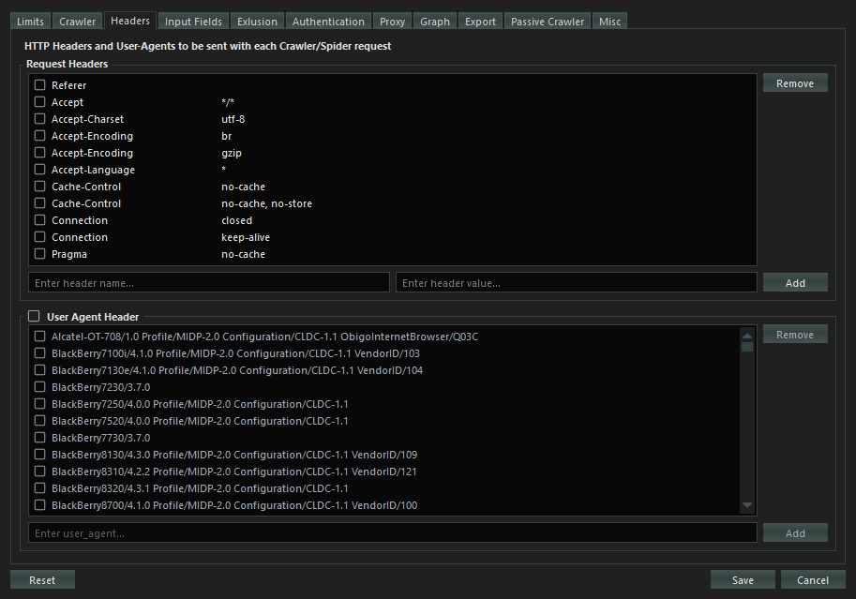

**Request Headers:**

Choose (check the header’s check box of ) the headers you want to use for crawling the target site. You can add your own custom headers by introducing the header name and value then click add button to add the new header to the headers list.

When checked (in use) the Referrer header value will be added automatically by the spider during the scan depending on where the link was extracted from.

**User Agent Header:**

The User-Agent request header is a characteristic string that lets servers and network peers identify the application, operating system, vendor, and/or version of the requesting user agent.

Check the (User Agent Header) checkbox to allow the use of user agents in crawling. Then choose the user agent(s) to use. If multiple user agents are chosen, they will all be used randomly for each request sent.

## Input Fields Configuration

Configures the default values for the listed common input name and types for HTML forms.

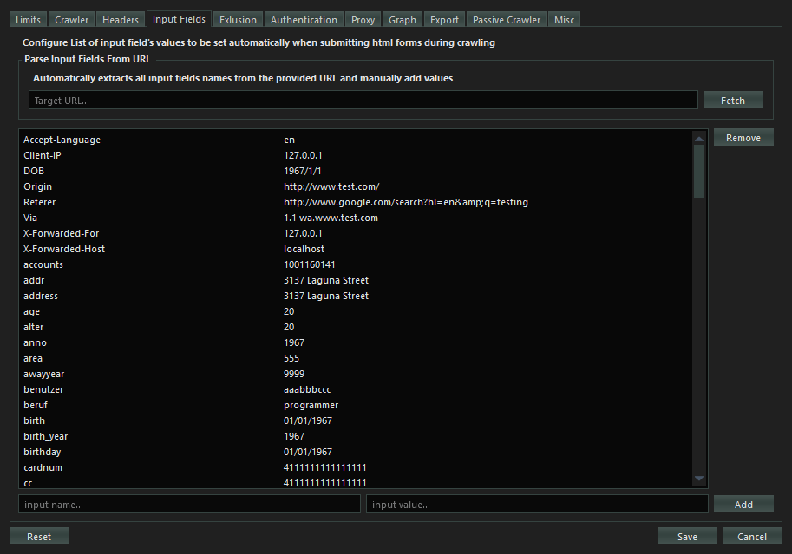

When crawling the HTML forms, values from all empty input values will be filled by the values from this list.

You can also add your own custom input name/type and value to be used in HTML form’s inputs. You can also parse and extract input fields from a URL automatically by fetching it then adding values to the input fields manually. ***This is more efficient and precise***.

## Exclusion Configuration

Configures what link’s query parameters, paths, extensions and cookies should be excluded from crawling.

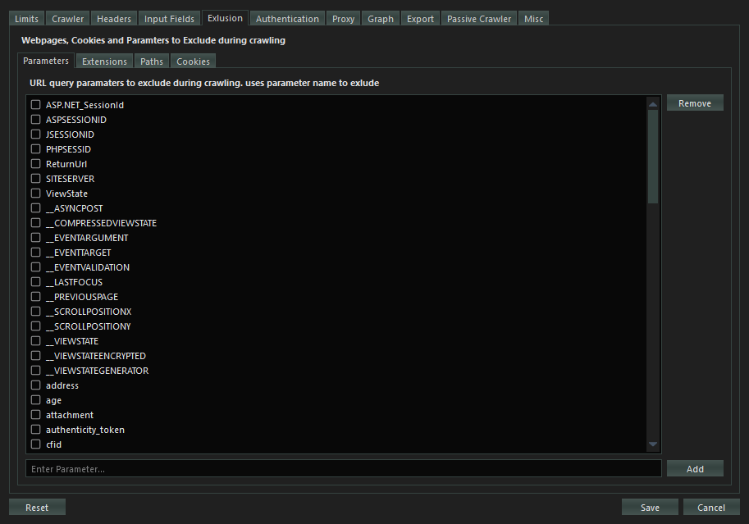

**Exclude Parameters:**

Configures which query parameters should be excluded from a network request if present. If exclude all parameters is chosen then query parameters from all links will be removed.

**Exclude File Extensions:**

Configures the Crawler to exclude crawling all links with file types of the specified extensions (pdf, exe, docx). You can add a file type extension to be excluded

**Exclude Paths:**

Configures the Crawler to exclude crawling the paths which match to the exclusion patterns. You can add custom excluded paths patterns (regular expression patterns) for each scan.

**Exclude Cookies:**

Configures the spider to exclude the chosen cookie patterns from the cookie jar. You can add custom cookie patterns (regular expression patterns) to exclude from the scan.

## Authentication Configuration

Configures the credentials for authenticated crawl.

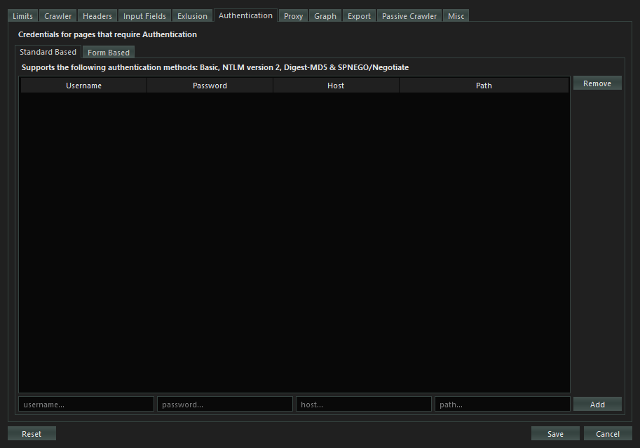

For current version 1.0.0 of SpiderSuite, it only supports standard based authentications which include `Basic`, `NTLM version 2`, `Digest-MD5` and `SPNEGO/Negotiate`.

Simply add the credential values; username, password, host site and the path that requires the authentication. After that you can check the credentials for it to be usable when the crawler detects authentication is required.

Form based authentication will be introduced in the coming versions of SpiderSuite.

## Proxy Configuration

Configures http and socks5 proxy connection for the crawler.

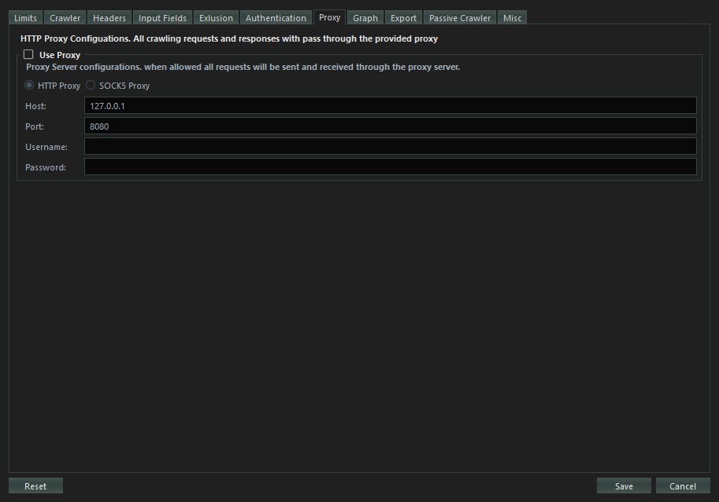

In case of anonymity or integration with other tools such as Burp Suite & Zed Attack Proxy (ZAP) and bypassing various IP related crawling drawbacks.

All crawler request and responses will pass through the configured proxy.

## Graph Configuration

Configures Graph visualizing the Crawled sitemap.

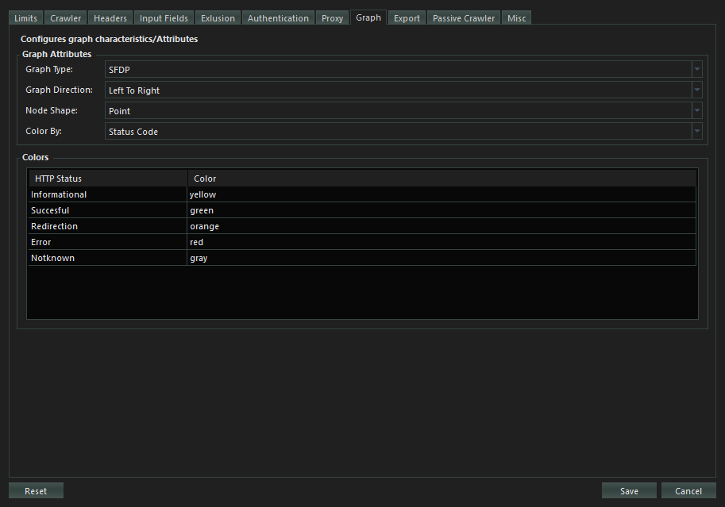

You can modify the graph appearance on your own liking for better data presentation.

## Configure Exports

Configures what data/information about a page should be exported on various export types.

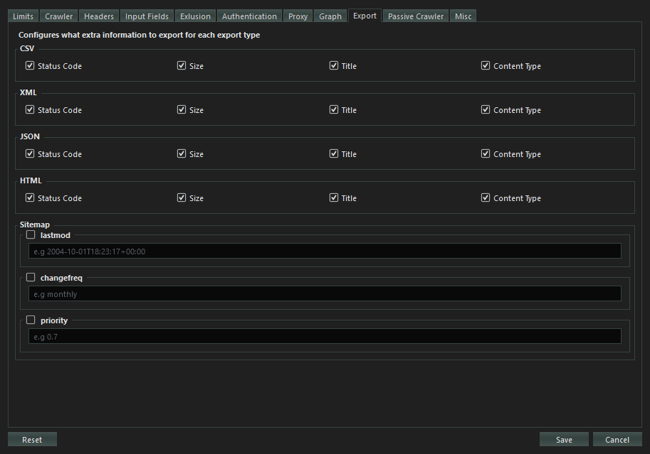

The page URLs will all be exported by default but other data about the webpage such as Status Code, Size, title and Content Type will only be exported when you choose them to be exported.

This feature gives control to the user on what data to be included in the export file.

## Passive Crawler Configuration

Configures the SpiderSuite passive crawler.

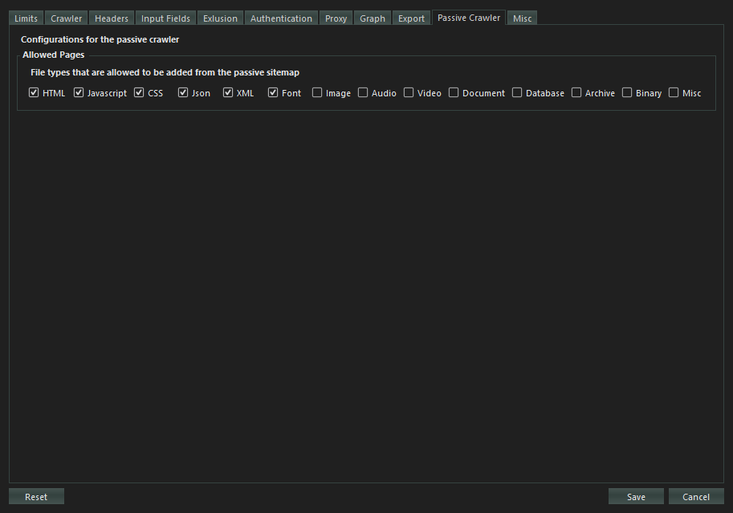

**Allowed Pages:**

Configures which pages (page type e.g. html, js, css ) are allowed to be added to the sitemap after the crawling is finished or when you add links.

## Misc Configuration

Miscellenious configurations.

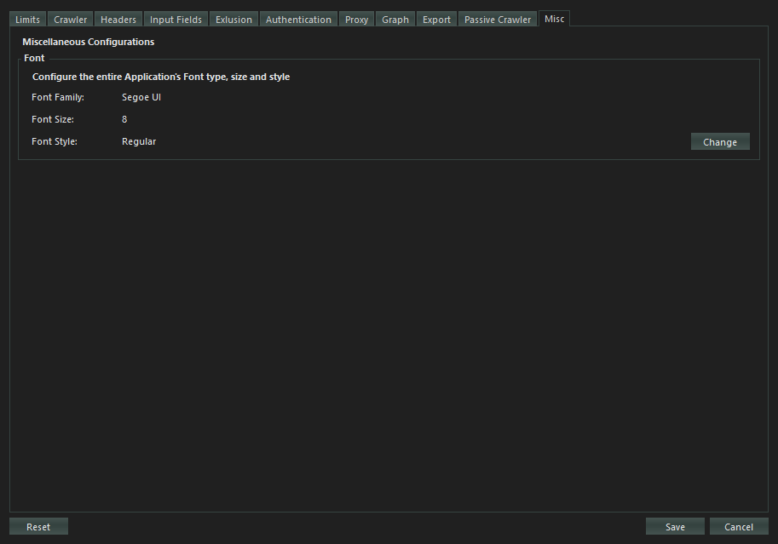

**Font:**

Configures the Spider Suite’s entire application font type, size and style, simply change the application’s font by using the font dialog.

The changes will take effect after restarting SpiderSuite.

# CRAWLING

The crawl phase of a scan involves navigating around the target web application, following links and submitting forms to catalog the content of the entire target web application and the navigational paths within it to create an accurate map of the target web application.

## Configure the crawler

Next step is to set the configurations for the crawler to run on.

***This is a very crucial step*** as the performance and success of the crawler depends on the configurations you have set. Take time to study the effects of all the Configurations

Click the C:\Users\inner peace\Desktop\Github\SpiderSuite.wiki\res\config_action.png ***config action*** on the toolbar to get access to the configuration dialog where you can set preferred configurations.

The configurations that affect the crawler are:

* **Limits**- Sets all the limitations for the crawler
* **Crawler**- Sets all the essential crawler configurations
* **Headers** - Sets the http request headers to be used by the crawler request.
* **Input Fields** - Sets the values for the page's input fields for automatic filling and submition.
* **Exclusion** - Sets the paths, cookies, file extensions and url parameters to be excluded for the crawl.
* **Authentication** - Sets values for automatic authentication by the crawler.
* **Proxy** - Sets the proxy address and port where all crawl request will pass through.

## Crawling from a Single Link

Spider Suite can crawl an entire target web application from a single link which acts as the root entry page for target web application.

To start crawling requires you to follow the following simple and few procedures.

1. **Input the target link**. Add the target URL link.



***Few things to Note:***

*Always make sure that you have input a valid URL with its protocol /schema.*

*-* ***Valid Links are:***

*https://example.com*

*https://example.com/*

*https://example.com/path1/path2*

*https://example.com:443/path1*

*https://127.0.0.1:80*

*-* ***Invalid Links are:***

*example.com*

*https://example/*

*https://example.com?param1=value1&param2=value2*

1. **Start Crawler**

Start the crawler by clicking on the `Crawl` button and the crawler with immediately start crawling the target web application.

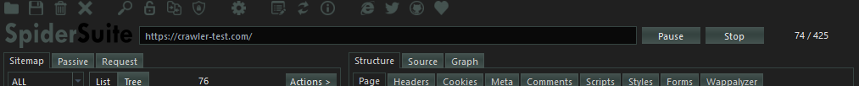

After starting the crawler, you can observer the crawler's `progress` on the far right corner which shows the number of pages crawled per all the pages available:

*progress = <pages\_crawled> / <total\_pages>.*

After crawler has started you have options to **Pause** or **Stop** the crawler.

**Pause Crawler:**

Spider Suite allows you to pause the crawler at any point during crawling and for any duration of time by pressing the **Pause** button.

After pressing **Pause** button the crawler immediately pauses sending the requests to the server or processing new replies `but` all the already finished and processed pages will still be added to the sitemap, so it’s not uncommon to pause the crawler and still seeing a few pages being added to the sitemap.

**Resume Crawler:**

After pausing the crawler you can resume crawling by pressing the `Resume` button and the crawler will immediately resume crawling the target web pages where it left of.

**Stop Crawler:**

You can stop the crawler at any point in time by pressing the `Stop` button. Stopping the crawler means that you terminate the crawler and you can no longer resume that particular crawl, all resources allocated are cleaned hence you can only start afresh from there.

After pressing **Stop** button the crawler immediately stops sending the requests to the server `but` it will wait until all the already sent request to be processed and added to the sitemap before it kills all the crawler threads. So it’s not uncommon to stop the crawler and still seeing a few pages being added to the sitemap as it will wait for all responses from the target server to be processed.

After stopping the crawler you may be prompted to save all the remaining target links that had'nt been crawled yet.

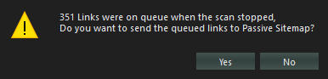

***If you accept*** all the pending links will be added to the passive crawler tool.

***If you deny*** all the pending links will be discarded.

## Advance Crawling

SpiderSuite has advance crawling options:

* Crawling target with initial seed links
* Fetching list of links
* Bruteforcing pages/directories

This advance crawling can be accessed by clicking on the **[...]** button.

C:\Users\inner peace\Desktop\Github\SpiderSuite.wiki\res\crawling_advance.png

## Crawling target with initial seed links

With SpiderSuite you have the ability to provide an initial list of links (`seed links`) of the particular target and they will be added to the crawler queue of links to be crawled.

* Enter Target link

C:\Users\inner peace\Desktop\Github\SpiderSuite.wiki\res\crawling_advance_crawl_target.png

* Add Seed links

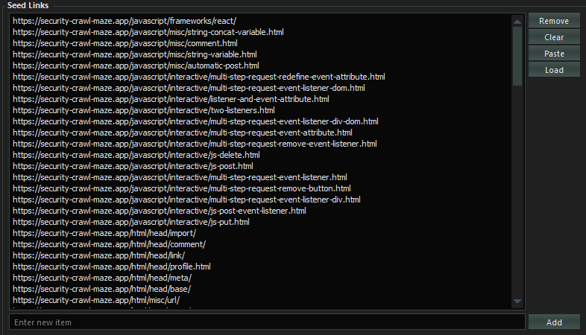

***Note:*** *The provided list of links should all relate (have the same hostname) to the main target link as the crawler uses the main target link as the reference point for all the links to be crawled.*

* Click on ***Crawl*** to begin crawling

C:\Users\inner peace\Desktop\Github\SpiderSuite.wiki\res\crawling_advance_crawl_start.png

## Fetching list of links

With SpiderSuite you also have the ability to fetch a provided list of links.

This type of crawling (fetching) does not crawl any additional links extracted from the crawled pages. Only the provided links will be crawled.

* You can provide file containing the list of links to be fetched. This is ideal for fectching a very long list of links as the file is not loaded into memory (it uses a streaming api to get line after line of link from the file and fetches it)

C:\Users\inner peace\Desktop\Github\SpiderSuite.wiki\res\crawling_fetch_file.png

* Or you can input the list of links to be fetched. This is ideal for fetching a small to medium list of links as the list is stored in memory.

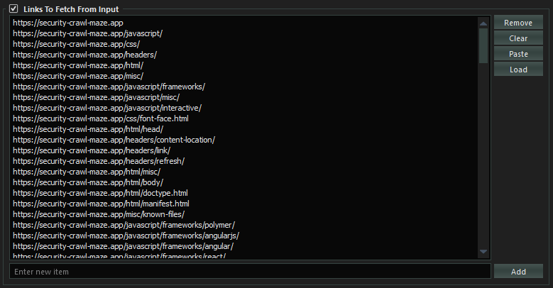

* Start the crawling by clicking on **Fetch** button.

C:\Users\inner peace\Desktop\Github\SpiderSuite.wiki\res\crawling_fetch_start.png

## Bruteforcing pages / directories

Lastly SpiderSuite also has the ability to bruteforce target sites's directories(pages). This is a useful feature for scoping directories and files that may be hidden.

* Set the target link (URL).

C:\Users\inner peace\Desktop\Github\SpiderSuite.wiki\res\crawling_brute_target.png

* You can provide file containing the wordlist pages/directories to be used for bruteforcing. This is ideal for bruteforcing with a very long wordlist as the file is not loaded into memory(it uses a streaming api to get line after line of page name from the file, append it to the target link and fetch it).

C:\Users\inner peace\Desktop\Github\SpiderSuite.wiki\res\crawling_brute_file.png

* Or you can input the wordlist for bruteforce. This is ideal for small to medium worldlist.

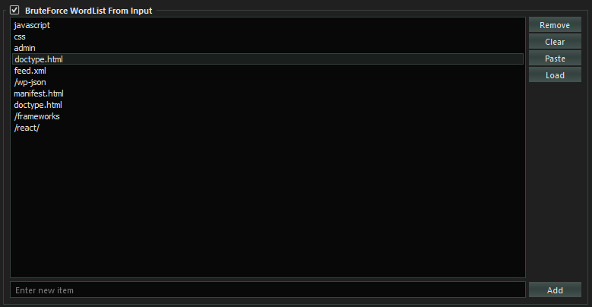

* Start bruteforcing by clicking on **Bruteforce** button.

C:\Users\inner peace\Desktop\Github\SpiderSuite.wiki\res\crawling_brute_start.png

## Sitemap

All the results from **Crawling**, **Fetching** and **Bruteforcing** will be displayed on Spider Suite's Sitemap.

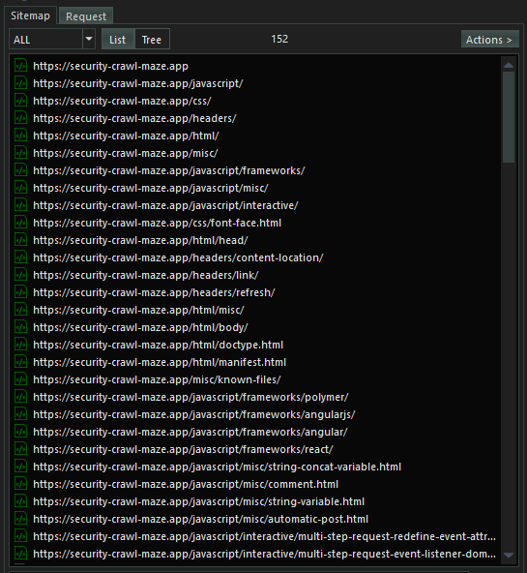

The actual pages are already saved on Spider Suite's current project database (.sspd) file.

To view content of any page on the sitemap simply click on it and all its content will be displayed on the structure and source tab.

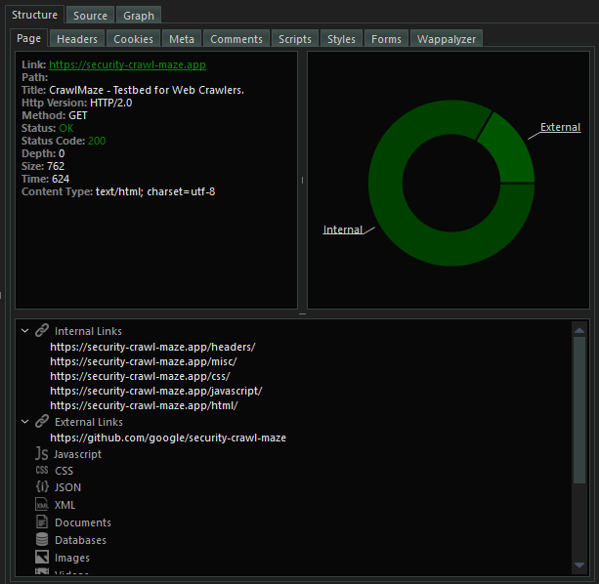

You can browse the structure and source tab to view all the content extracted from the particular page you clicked on.

You can perform desired actions on a page on sitemap by right clicking on it and choosing the action you want to perform.

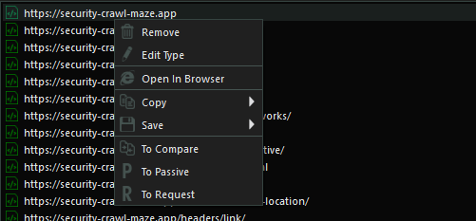

Or

You can perform desired actions on the entire list on sitemap by clicking on the **Actions** button. Please note that the Actions button is only activated if there are links on the sitemap.

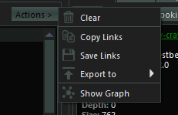

## Graph

SpiderSuite has the capabilities of visualizing the links on the sitemap using a graph and also ability to manipulate the graph to your liking.

* Visualize the Entire sitemap's on a graph.

Simply click on the **Actions** button and click on **Show Graph** action to visualize the graph.

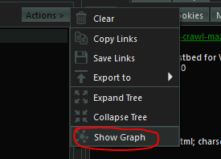

* Visualize a sitemap branch on a graph.

First change the Sitemap's view to **Tree** view.

C:\Users\inner peace\Desktop\Github\SpiderSuite.wiki\res\crawling_graph_tree.png

Then simply **right click** on the branch you want to visualize and click on **Show Graph**. This will only show the graph for that particular chosen branch.

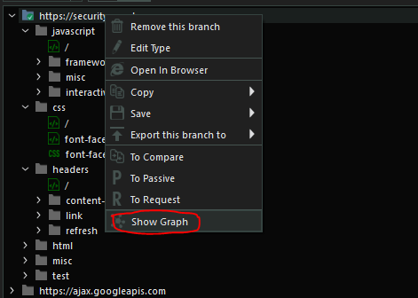

**The Graph:**

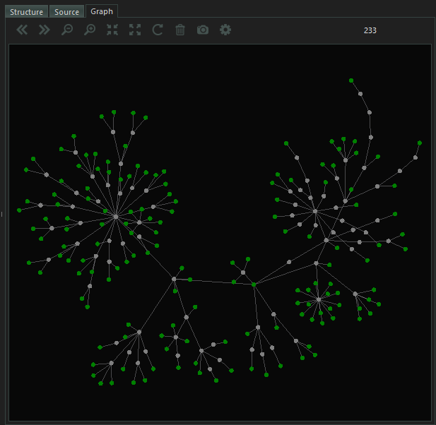

- You can manipulate the graph to you linking by simply clicking on the C:\Users\inner peace\Desktop\Github\SpiderSuite.wiki\res\config_action.png **config action** icon on graph menu bar and set your desired configurations.

# TOOLS

List of Tools Available in Spider Suite version 1.0.0

## Passive Crawler Tool

Uses OSINT (open source intelligence) sources: **waybackmachine** and **Arquivo** to obtain all publicly available url links of the target. You can use the obtained links as seed links for the next crawl.

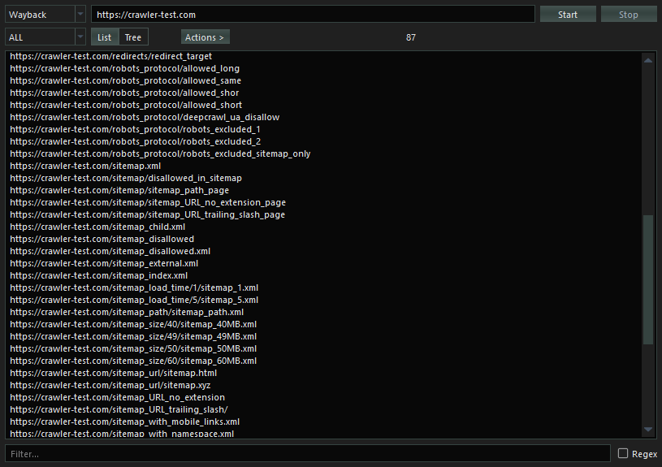

## SSL Certificates Tool

Fetches SSL certificates of a particular target hostname. It does this by trying to establish a secure connection to the hostname and when done it returns the target hostname SSL certificate and closes the connection.

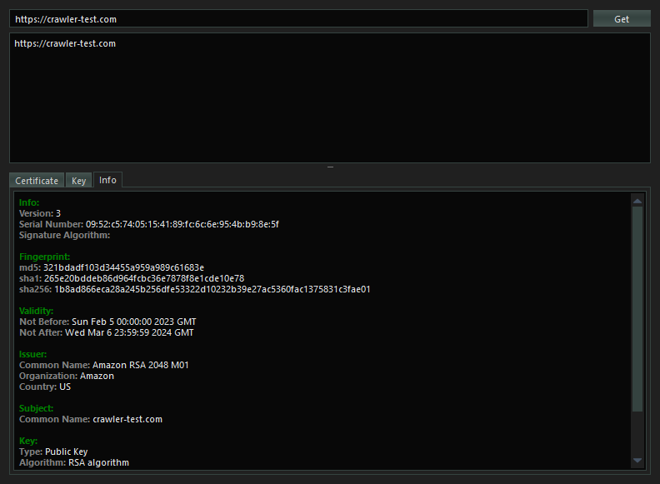

## Decoder Tool

**Encodes**, **Decodes** or **Hashes** the input data using the chosen encoding, decoding or hashing algorithm.

* **Encoding algorithms**: URL, HTML, Base64, Hex, Gzip and Brotli
* **Hashing algorithms**: Md4, Md5, Sha1, Sha224, Sha256, Sha384, Sha512, Sha3\_224, Sha3\_256, Sha3\_384, Sha3\_512, Keccak\_224, Keccak\_256, Keccak\_384, Keccak\_512

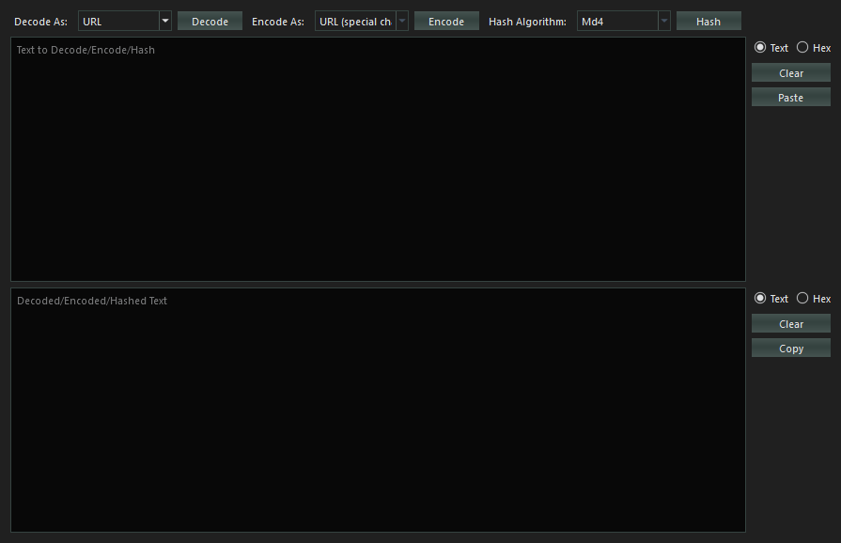

Many other encoding,decoding and hashing algorithms will be added in the coming versions.

## Search Tool

Searches the current project’s data in the database and returns all the pages that contains that particular search query. The search can take a long or short period depending on the size of the project.

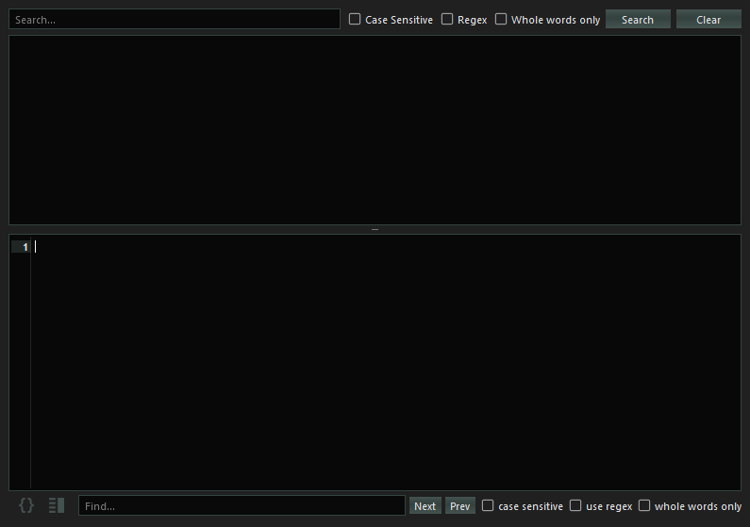

## Compare Tool

Compares two different pages or crawls then highlights the differences and similarities of the two pages or crawls.

* **Compare Pages**

Compares two pages for any differences and similarities.

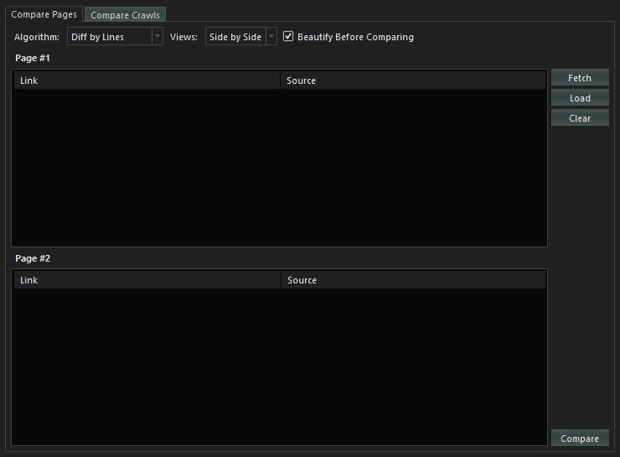

* **Compare Crawls**

Compares two project crawls for any differences among similar pages.

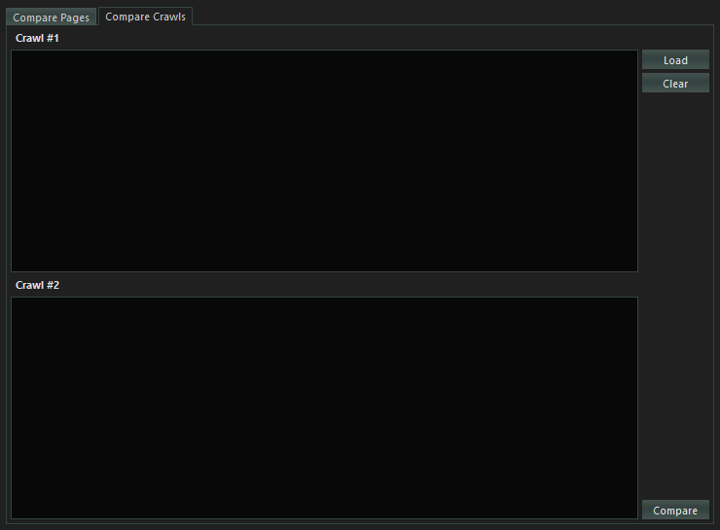

# CONTACTS

You can contact us by email, twitter or telegram chat for any issue or inquiry and we  
will get back to you as soon as possible.

**Email:**

[spid3rsuite@gmail.com](mailto:spid3rsuite@gmail.com)

[enock.n.michael@gmail.com](mailto:enock.n.michael@gmail.com)

**Twitter:**

<https://twitter.com/spider_suite>

**Telegram chat:**

<https://t.me/SpiderSuite>